[Skip to content](https://github.com/devsuperior/sds-dsmovie/tree/main/episodio2#start-of-content)

Parte superior do formulário



Parte inferior do formulário

[**Pull requests**](https://github.com/pulls)[**Issues**](https://github.com/issues)

[**Marketplace**](https://github.com/marketplace)

[**Explore**](https://github.com/explore)

Parte superior do formulário

Parte inferior do formulário

@Adolfinhof

# [devsuperior](https://github.com/devsuperior)/[sds-dsmovie](https://github.com/devsuperior/sds-dsmovie)Public

* Watch 10

Parte superior do formulário

Fork 49

Parte inferior do formulário

Parte superior do formulário

 Star 148

Parte inferior do formulário

* [**Code**](https://github.com/devsuperior/sds-dsmovie)
* [Issues1](https://github.com/devsuperior/sds-dsmovie/issues)
* [Pull requests](https://github.com/devsuperior/sds-dsmovie/pulls)
* [Actions](https://github.com/devsuperior/sds-dsmovie/actions)
* [Projects](https://github.com/devsuperior/sds-dsmovie/projects?type=beta)
* [Wiki](https://github.com/devsuperior/sds-dsmovie/wiki)
* [Security](https://github.com/devsuperior/sds-dsmovie/security)
* [Insights](https://github.com/devsuperior/sds-dsmovie/pulse)

 main

[sds-dsmovie](https://github.com/devsuperior/sds-dsmovie)/**episodio2**/

[Go to file](https://github.com/devsuperior/sds-dsmovie/find/main)Add file

## Latest commit

[@acenelio](https://github.com/acenelio)

[**acenelio**](https://github.com/devsuperior/sds-dsmovie/commits?author=acenelio) [Ep3](https://github.com/devsuperior/sds-dsmovie/commit/03f57609a3e8da9cd67c85bda4b2f813adfccd7c)

[03f57607 hours ago](https://github.com/devsuperior/sds-dsmovie/commit/03f57609a3e8da9cd67c85bda4b2f813adfccd7c)

## Git stats

* [**History**](https://github.com/devsuperior/sds-dsmovie/commits/main/episodio2)

## Files

Type

Name

Latest commit message

Commit time

[. .](https://github.com/devsuperior/sds-dsmovie)

[README.md](https://github.com/devsuperior/sds-dsmovie/blob/main/episodio2/README.md)

[Ep3](https://github.com/devsuperior/sds-dsmovie/commit/03f57609a3e8da9cd67c85bda4b2f813adfccd7c)

7 hours ago

## [README.md](https://github.com/devsuperior/sds-dsmovie/tree/main/episodio2#readme)

# [DevSuperior logo](https://raw.githubusercontent.com/devsuperior/bds-assets/main/ds/devsuperior-logo-small.png) Semana Spring React - Episódio 2

Crie um app inédito para seu portfólio com as tecnologias mais demandadas do mercado

## Realização

[DevSuperior - Escola de programação](https://devsuperior.com.br/)

[DevSuperior no Instagram](https://instagram.com/devsuperior.ig) [DevSuperior no Youtube](https://youtube.com/devsuperior)

## Objetivos do projeto para esta aula

* Implementar o back end
* Modelo de domínio
* Acesso a banco de dados
* Estruturar o back end no padrão camadas
* Criar endpoints da API REST
* Implantação na nuvem

## AVISO: as aulas ficarão disponíveis somente até domingo às 23h59

## AVISO: Instruções sobre certificado no Github do [aqui](https://github.com/devsuperior/sds-dsmovie/tree/main/_certificado)

## Checklist

### Passo: configuração de segurança

@Configuration

@EnableWebSecurity

public class SecurityConfig extends WebSecurityConfigurerAdapter {

@Autowired

private Environment env;

@Override

protected void configure(HttpSecurity http) throws Exception {

if (Arrays.asList(env.getActiveProfiles()).contains("test")) {

http.headers().frameOptions().disable();

}

http.cors().and().csrf().disable();

http.sessionManagement().sessionCreationPolicy(SessionCreationPolicy.STATELESS);

http.authorizeRequests().anyRequest().permitAll();

}

@Bean

CorsConfigurationSource corsConfigurationSource() {

CorsConfiguration configuration = new CorsConfiguration().applyPermitDefaultValues();

configuration.setAllowedMethods(Arrays.asList("POST", "GET", "PUT", "DELETE", "OPTIONS"));

final UrlBasedCorsConfigurationSource source = new UrlBasedCorsConfigurationSource();

source.registerCorsConfiguration("/**", configuration);

return source;

}

}

* **COMMIT: Security config**

### Passo: criar as entidades e o seed do banco

#### Modelo conceitual

[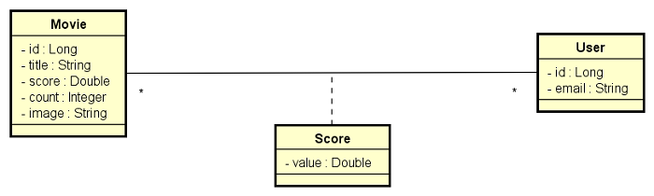](https://raw.githubusercontent.com/devsuperior/bds-assets/main/sds/dsmovie-dominio.png)

#### application.properties

spring.profiles.active=test

spring.jpa.open-in-view=false

#### application-test.properties

# Dados de conexão com o banco H2

spring.datasource.url=jdbc:h2:mem:testdb

spring.datasource.username=sa

spring.datasource.password=

# Configuração do cliente web do banco H2

spring.h2.console.enabled=true

spring.h2.console.path=/h2-console

# Configuração para mostrar o SQL no console

spring.jpa.show-sql=true

spring.jpa.properties.hibernate.format_sql=true

#### import.sql

INSERT INTO tb_user(email) VALUES ('maria@gmail.com');

INSERT INTO tb_user(email) VALUES ('joao@gmail.com');

INSERT INTO tb_user(email) VALUES ('ana@gmail.com');

INSERT INTO tb_user(email) VALUES ('lucia@gmail.com');

INSERT INTO tb_user(email) VALUES ('joaquim@gmail.com');

INSERT INTO tb_movie(score, count, title, image) VALUES (4.5, 2, 'The Witcher', 'https://www.themoviedb.org/t/p/w533_and_h300_bestv2/jBJWaqoSCiARWtfV0GlqHrcdidd.jpg');

INSERT INTO tb_movie(score, count, title, image) VALUES (3.3, 3, 'Venom: Tempo de Carnificina', 'https://www.themoviedb.org/t/p/w533_and_h300_bestv2/vIgyYkXkg6NC2whRbYjBD7eb3Er.jpg');

INSERT INTO tb_movie(score, count, title, image) VALUES (0, 0, 'Shang-Chi e a Lenda dos Dez Anéis', 'https://www.themoviedb.org/t/p/w533_and_h300_bestv2/cinER0ESG0eJ49kXlExM0MEWGxW.jpg');

INSERT INTO tb_movie(score, count, title, image) VALUES (0, 0, 'Matrix Resurrections', 'https://www.themoviedb.org/t/p/w533_and_h300_bestv2/hv7o3VgfsairBoQFAawgaQ4cR1m.jpg');

INSERT INTO tb_movie(score, count, title, image) VALUES (0, 0, 'Shang-Chi e a Lenda dos Dez Anéis', 'https://www.themoviedb.org/t/p/w533_and_h300_bestv2/cinER0ESG0eJ49kXlExM0MEWGxW.jpg');

INSERT INTO tb_movie(score, count, title, image) VALUES (0, 0, 'Matrix Resurrections', 'https://www.themoviedb.org/t/p/w533_and_h300_bestv2/hv7o3VgfsairBoQFAawgaQ4cR1m.jpg');

INSERT INTO tb_movie(score, count, title, image) VALUES (0, 0, 'Shang-Chi e a Lenda dos Dez Anéis', 'https://www.themoviedb.org/t/p/w533_and_h300_bestv2/cinER0ESG0eJ49kXlExM0MEWGxW.jpg');

INSERT INTO tb_movie(score, count, title, image) VALUES (0, 0, 'Matrix Resurrections', 'https://www.themoviedb.org/t/p/w533_and_h300_bestv2/hv7o3VgfsairBoQFAawgaQ4cR1m.jpg');

INSERT INTO tb_movie(score, count, title, image) VALUES (0, 0, 'Shang-Chi e a Lenda dos Dez Anéis', 'https://www.themoviedb.org/t/p/w533_and_h300_bestv2/cinER0ESG0eJ49kXlExM0MEWGxW.jpg');

INSERT INTO tb_movie(score, count, title, image) VALUES (0, 0, 'Matrix Resurrections', 'https://www.themoviedb.org/t/p/w533_and_h300_bestv2/hv7o3VgfsairBoQFAawgaQ4cR1m.jpg');

INSERT INTO tb_movie(score, count, title, image) VALUES (0, 0, 'Shang-Chi e a Lenda dos Dez Anéis', 'https://www.themoviedb.org/t/p/w533_and_h300_bestv2/cinER0ESG0eJ49kXlExM0MEWGxW.jpg');

INSERT INTO tb_movie(score, count, title, image) VALUES (0, 0, 'Matrix Resurrections', 'https://www.themoviedb.org/t/p/w533_and_h300_bestv2/hv7o3VgfsairBoQFAawgaQ4cR1m.jpg');

INSERT INTO tb_movie(score, count, title, image) VALUES (0, 0, 'Shang-Chi e a Lenda dos Dez Anéis', 'https://www.themoviedb.org/t/p/w533_and_h300_bestv2/cinER0ESG0eJ49kXlExM0MEWGxW.jpg');

INSERT INTO tb_movie(score, count, title, image) VALUES (0, 0, 'Matrix Resurrections', 'https://www.themoviedb.org/t/p/w533_and_h300_bestv2/hv7o3VgfsairBoQFAawgaQ4cR1m.jpg');

INSERT INTO tb_movie(score, count, title, image) VALUES (0, 0, 'Shang-Chi e a Lenda dos Dez Anéis', 'https://www.themoviedb.org/t/p/w533_and_h300_bestv2/cinER0ESG0eJ49kXlExM0MEWGxW.jpg');

INSERT INTO tb_movie(score, count, title, image) VALUES (0, 0, 'Matrix Resurrections', 'https://www.themoviedb.org/t/p/w533_and_h300_bestv2/hv7o3VgfsairBoQFAawgaQ4cR1m.jpg');

INSERT INTO tb_movie(score, count, title, image) VALUES (0, 0, 'Shang-Chi e a Lenda dos Dez Anéis', 'https://www.themoviedb.org/t/p/w533_and_h300_bestv2/cinER0ESG0eJ49kXlExM0MEWGxW.jpg');

INSERT INTO tb_movie(score, count, title, image) VALUES (0, 0, 'Matrix Resurrections', 'https://www.themoviedb.org/t/p/w533_and_h300_bestv2/hv7o3VgfsairBoQFAawgaQ4cR1m.jpg');

INSERT INTO tb_movie(score, count, title, image) VALUES (0, 0, 'Shang-Chi e a Lenda dos Dez Anéis', 'https://www.themoviedb.org/t/p/w533_and_h300_bestv2/cinER0ESG0eJ49kXlExM0MEWGxW.jpg');

INSERT INTO tb_movie(score, count, title, image) VALUES (0, 0, 'Matrix Resurrections', 'https://www.themoviedb.org/t/p/w533_and_h300_bestv2/hv7o3VgfsairBoQFAawgaQ4cR1m.jpg');

INSERT INTO tb_movie(score, count, title, image) VALUES (0, 0, 'Shang-Chi e a Lenda dos Dez Anéis', 'https://www.themoviedb.org/t/p/w533_and_h300_bestv2/cinER0ESG0eJ49kXlExM0MEWGxW.jpg');

INSERT INTO tb_movie(score, count, title, image) VALUES (0, 0, 'Matrix Resurrections', 'https://www.themoviedb.org/t/p/w533_and_h300_bestv2/hv7o3VgfsairBoQFAawgaQ4cR1m.jpg');

INSERT INTO tb_movie(score, count, title, image) VALUES (0, 0, 'Shang-Chi e a Lenda dos Dez Anéis', 'https://www.themoviedb.org/t/p/w533_and_h300_bestv2/cinER0ESG0eJ49kXlExM0MEWGxW.jpg');

INSERT INTO tb_movie(score, count, title, image) VALUES (0, 0, 'Matrix Resurrections', 'https://www.themoviedb.org/t/p/w533_and_h300_bestv2/hv7o3VgfsairBoQFAawgaQ4cR1m.jpg');

INSERT INTO tb_movie(score, count, title, image) VALUES (0, 0, 'Shang-Chi e a Lenda dos Dez Anéis', 'https://www.themoviedb.org/t/p/w533_and_h300_bestv2/cinER0ESG0eJ49kXlExM0MEWGxW.jpg');

INSERT INTO tb_movie(score, count, title, image) VALUES (0, 0, 'Matrix Resurrections', 'https://www.themoviedb.org/t/p/w533_and_h300_bestv2/hv7o3VgfsairBoQFAawgaQ4cR1m.jpg');

INSERT INTO tb_movie(score, count, title, image) VALUES (0, 0, 'Shang-Chi e a Lenda dos Dez Anéis', 'https://www.themoviedb.org/t/p/w533_and_h300_bestv2/cinER0ESG0eJ49kXlExM0MEWGxW.jpg');

INSERT INTO tb_movie(score, count, title, image) VALUES (0, 0, 'Matrix Resurrections', 'https://www.themoviedb.org/t/p/w533_and_h300_bestv2/hv7o3VgfsairBoQFAawgaQ4cR1m.jpg');

INSERT INTO tb_movie(score, count, title, image) VALUES (0, 0, 'Shang-Chi e a Lenda dos Dez Anéis', 'https://www.themoviedb.org/t/p/w533_and_h300_bestv2/cinER0ESG0eJ49kXlExM0MEWGxW.jpg');

INSERT INTO tb_movie(score, count, title, image) VALUES (0, 0, 'Matrix Resurrections', 'https://www.themoviedb.org/t/p/w533_and_h300_bestv2/hv7o3VgfsairBoQFAawgaQ4cR1m.jpg');

INSERT INTO tb_score(movie_id, user_id, value) VALUES (1, 1, 5.0);

INSERT INTO tb_score(movie_id, user_id, value) VALUES (1, 2, 4.0);

INSERT INTO tb_score(movie_id, user_id, value) VALUES (2, 1, 3.0);

INSERT INTO tb_score(movie_id, user_id, value) VALUES (2, 2, 3.0);

INSERT INTO tb_score(movie_id, user_id, value) VALUES (2, 3, 4.0);

* **COMMIT: Domain model, database seed**

### Passo: Busca de filmes

#### Padrão camadas adotado

[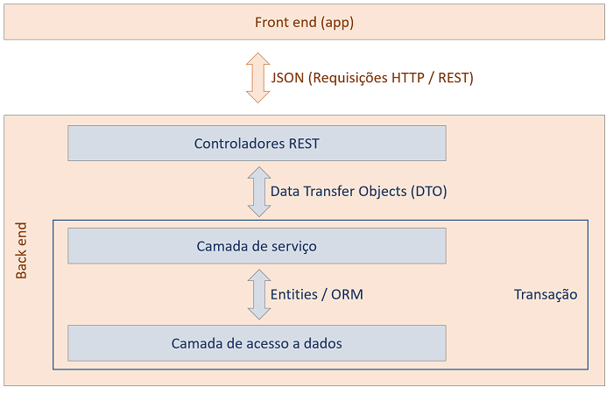](https://github.com/devsuperior/bds-assets/raw/main/sds/padrao-camadas.png)

* Criar repository
* Criar DTO
* Criar service
* Criar controller
* **COMMIT: Find movies**

### Passo: Salvar avaliação

#### Lógica:

1. Informar email, id do filme e valor da avaliação (1 a 5).
2. Recuperar usuário do banco de dados pelo email. Se o usuário não existir, insira no banco.
3. Salvar a avaliação do usuário para o dado filme.
4. Recalcular a avaliação média do filme e salvar no banco de dados.

[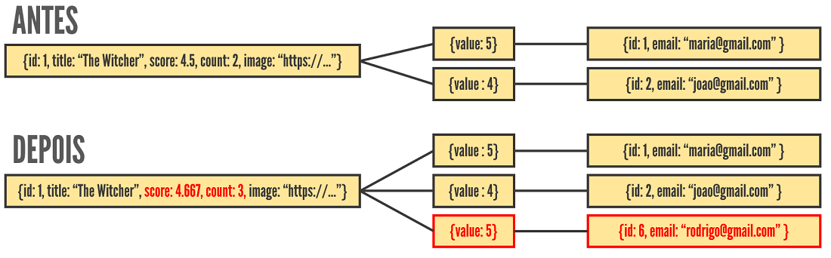](https://raw.githubusercontent.com/devsuperior/bds-assets/main/sds/dsmovie-objs.png)

* **COMMIT: Save score**

### Passo: Validação no Postgres local

* Criar três perfis de projeto: test, dev, prod
* Gerar script SQL no perfil dev
* Testar projeto no banco Postgres local

#### application-dev.properties

#spring.jpa.properties.javax.persistence.schema-generation.create-source=metadata

#spring.jpa.properties.javax.persistence.schema-generation.scripts.action=create

#spring.jpa.properties.javax.persistence.schema-generation.scripts.create-target=create.sql

#spring.jpa.properties.hibernate.hbm2ddl.delimiter=;

spring.datasource.url=jdbc:postgresql://localhost:5432/dsmovie

spring.datasource.username=postgres

spring.datasource.password=1234567

spring.jpa.properties.hibernate.jdbc.lob.non_contextual_creation=true

spring.jpa.hibernate.ddl-auto=none

#### application-prod.properties

spring.datasource.url=${DATABASE_URL}

#### system.properties

java.runtime.version=17

* **COMMIT: First homolog**

### Passo: Implantação no Heroku

* Criar app no Heroku
* Provisionar banco Postgres
* Definir variável APP_PROFILE=prod
* Conectar ao banco via pgAdmin
* Criar seed do banco

heroku -v

heroku login

heroku git:remote -a <nome-do-app>

git remote -v

git subtree push --prefix backend heroku main

### Passo: implantação no Netlify

* Deploy básico
  + Base directory: frontend
  + Build command: yarn build
  + Publish directory: frontend/build
* Arquivo _redirects

/* /index.html 200

* Configurações adicionais
  + Site settings -> Domain Management: (colocar o nome que você quiser)
  + Deploys -> Trigger deploy

## PARABÉNS!

[](https://raw.githubusercontent.com/devsuperior/bds-assets/main/img/trophy.png)

* Quero muito saber seu feedback
  + O que você está achando da nossa abordagem?
  + Você está conseguindo acompanhar?
  + O que você está achando do evento?
* Participe
  + Comente na página da Semana Spring React
  + Divulgue seu projeto no Linkedin e marque a DevSuperior
* © 2022 GitHub, Inc.
* [Terms](https://docs.github.com/en/github/site-policy/github-terms-of-service)
* [Privacy](https://docs.github.com/en/github/site-policy/github-privacy-statement)
* [Security](https://github.com/security)
* [Status](https://www.githubstatus.com/)
* [Docs](https://docs.github.com/)
* [Contact GitHub](https://support.github.com/?tags=dotcom-footer)
* [Pricing](https://github.com/pricing)
* [API](https://docs.github.com/)
* [Training](https://services.github.com/)
* [Blog](https://github.blog/)
* [About](https://github.com/about)

Loading complete